WAMBUGU ROBERT NJENGA
I39/2209/2013

2 BY 4 BINARY DECODER REPORT
INTRODUCTION
Decoders are simply a collection of logic gates which are arranged in a specific way so as to breakdown any combination of inputs to a set of terms that are all set to '0' apart from one term. Therefore when one input changes, two output terms will change. Note that these terms are "minterms", remembering that minterms use a variable once, and once only.
Lets say we have N inputs to a decoder, the number of outputs will be equal to 2^N. Thus there will be one line at the output for each possible input.
System c enables us to simulate this arrangement of gates using coding.
A two by Four decoder outputs two signal corresponding to a binary type input at each wire. For it has two inputs but gives out four outputs. As shown below.
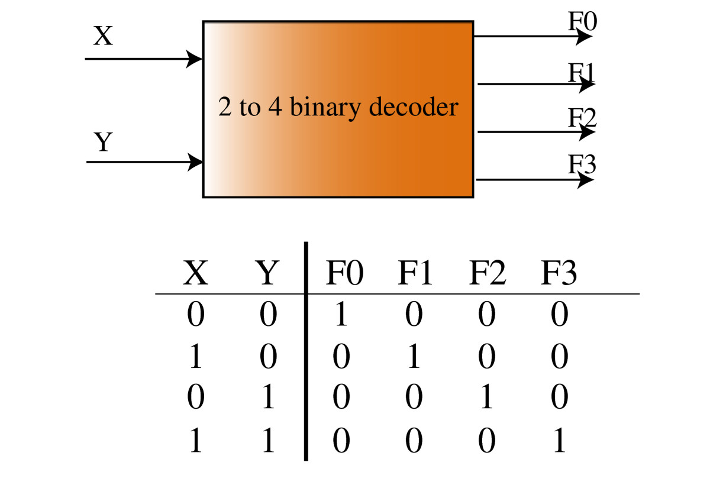
This was implemented in system c by setting up 3 MODULES namely :
DRIVER MODULE;
It yields forth the two signals to be decoded.
DECODER MODULE;
Uses inputs yielded by driver as inputs and gives forth a set of outputs
MONITOR MODULE;
It monitors and determines the behavior of the input and outputs with time to make sure that the outputs and inputs “behaves”.
HERE IS HOW THE MODULES WERE FORMULATED

BASE CODE DECODER.CC
#include "driver2by4.h"
#include "decoder2by4.h"
#include "monitor2by4.h"
#include <systemc.h>

int sc_main(int argc, char *argv[])
{
sc_signal<bool> in_1, in_2, out_1, out_2, out_3, out_4; //signals to connect different modules

decoder THEDecode("decoder_instance");
driver THEDriver("driver");
monitor THEMonitor("monitor");

//inputs format: module instance
THEDriver.d1(in_1);
THEDriver.d2(in_2);
THEMonitor.in__1(in_1); //monitor for inputs
THEMonitor.in__2(in_2);
THEDecode.b1(in_1);
THEDecode.b2(in_2);

// outputs format: module instance at declaired port
THEDecode.d0(out_1);
THEDecode.d1(out_2);
THEDecode.d2(out_3);
THEDecode.d3(out_4);
THEMonitor.out__1(out_1);
THEMonitor.out__2(out_2);
THEMonitor.out__3(out_3);
THEMonitor.out__4(out_4);

// CREATING TRACE FILE
sc_trace_file *tf;
tf= sc_create_vcd_trace_file("timing_diagram"); //sets the name of the file
tf->set_time_unit(1, SC_NS);

//modules for trace & signals interconnecting
sc_trace(tf, in_1, "binary_input_one"); // signals to be traced
sc_trace(tf, in_2, "binary_input_two"); //label of the 'axes'
sc_trace(tf, out_4, "input_is_three");
sc_trace(tf, out_3, "input_is_two");
sc_trace(tf, out_2, "input_is_one");
sc_trace(tf, out_1, "input_is_zero");

if( !sc_pending_activity() )
sc_start(75,SC_NS);
//close the trace file
sc_close_vcd_trace_file(tf);

return 0;
}

DRIVER MODULE
#include<systemc.h>

SC_MODULE(driver)
{
sc_out<bool> d1,d2;

SC_CTOR(driver){
SC_THREAD(Drive);
}

void startDrive(void)
{
while(1)
{
d1=0;
d2=0;
wait(5,SC_NS);
d2=1;
wait(5,SC_NS);
d1=1;
d2=0;
wait(5,SC_NS);
d2=1;
wait(5,SC_NS);
}

}
};

DECODER MODULE
#include<systemc.h>
//decoder module
SC_MODULE(decoder)
{
//input and output ports
sc_in<bool> b0,b1;
// sc_in<bool>b1;
sc_out<bool> d0,d1,d2,d3;

SC_CTOR(decoder)
{
SC_METHOD(decode);
sensitive<<b0<<b1;
}

~decoder(){
//delete stuff :P
}

void decode (void)
{

if (b0==0 && b1==0){
d0=1;
d3=0; }
else if (b0==0 && b1==1){
d1=1;
d0=0;
}
else if (b0==1 && b1==0){
d2=1;
d1=0;
}
else if (b0==1 && b1==1){
d3=1;
d2=0;

}

}
};

MONITOR MODULE

#include <iostream>
#include<systemc>

using namespace std;

SC_MODULE(monitor)
{
sc_in<bool> in__1,in__2,out__1,out__2,out__3,out__4;

SC_CTOR(monitor)
{
SC_METHOD(monitoring);
sensitive<< out__1<< out__2<<out__3<< out__4; //setting the sensitivity
dont_initialize();

}

void monitoring(void)
{
cout<<"At "<<sc_time_stamp()<<" inputs are "<<in__1<<" and "<<in__2<<" the outputs are "<<out__1<<", "<<out__2<<", "<<out__3<<", "<<out__4<<endl;
}

};

When all of these was run in Eclipse Mars the output at command line was as follows.

0 s inputs are 0 and 0 the outputs are 0, 0, 0, 1
5 ns inputs are 0 and 1 the outputs are 0, 0, 1, 0
10 ns inputs are 1 and 0 the outputs are 0, 1, 0, 0
15 ns inputs are 1 and 1 the outputs are 1, 0, 0, 0
20 ns inputs are 0 and 0 the outputs are 0, 0, 0, 1
25 ns inputs are 0 and 1 the outputs are 0, 0, 1, 0
30 ns inputs are 1 and 0 the outputs are 0, 1, 0, 0
35 ns inputs are 1 and 1 the outputs are 1, 0, 0, 0
40 ns inputs are 0 and 0 the outputs are 0, 0, 0, 1

DISCUSSIONS
The implementation of a 2by4 decoder was achieved successfully as seen from the values on the command-line. Showing that for every binary input the output is a decimal value.
CONCLUSION
Implementation and simulation of a 2by4 decoder is possible with system c.
REFERENCES
References
1.A SystemC Primer
J. BHASKER
Published by
Star Galaxy Publishing
015 Treeline Drive, Allentown,PA 18103
2.SystemC:
From the Ground Up
D.C. Black, J. Donovan, B. Bunton, A. Keist

